## **“Thank You” House Help: “Thank You” Dr. Morepen**

***₹499 for a 1-year Multivitamin Pack***

**Gurugram, May 1, 2025:** This Labour Day, **Dr. Morepen** says “**Thank You**” to the domestic helpers, drivers, guards, nannies, and countless others who make our lives and build a healthy nation when it launches a powerpack multivitamin (with 19 essential vitamins) called **“Thank You”** for those who need it most. It is a health supplement rich in Vit C, Vit B, folic acid, essential minerals like zinc, magnesium, iodine and biotin. This is not just a product, but a mission full of gratitude to offer a “Thank You”, a wholesome multivitamin initiative that extends care and dignity to those who work behind the scenes in our lives.

Priced at just ₹499 for 1-year supply (for less than cup of a good coffee), this initiative is aligned with the vision of our Hon’ble Prime Minister which affirms - Health for All. Dr. Morepen ‘**Thank You’** is a scientifically formulated multivitamin pack designed for the undernourished and nutrient-deficient—those who can’t afford basic nutrition despite working tirelessly every day. It is time to say **“Thank you”** to them by buying this power packed gift of multivitamin for them.

*“This is our way of saying we see you, we appreciate you, and we care. The people who support our lives deserve more than a Thank You—they deserve Good Health. This health movement is for the nation, for those who build it.* *Gift this to those who serve you.* ***One pack-One life Changed****. ”* **said Mr. Varun Suri, Managing Director, Dr. Morepen Limited.**

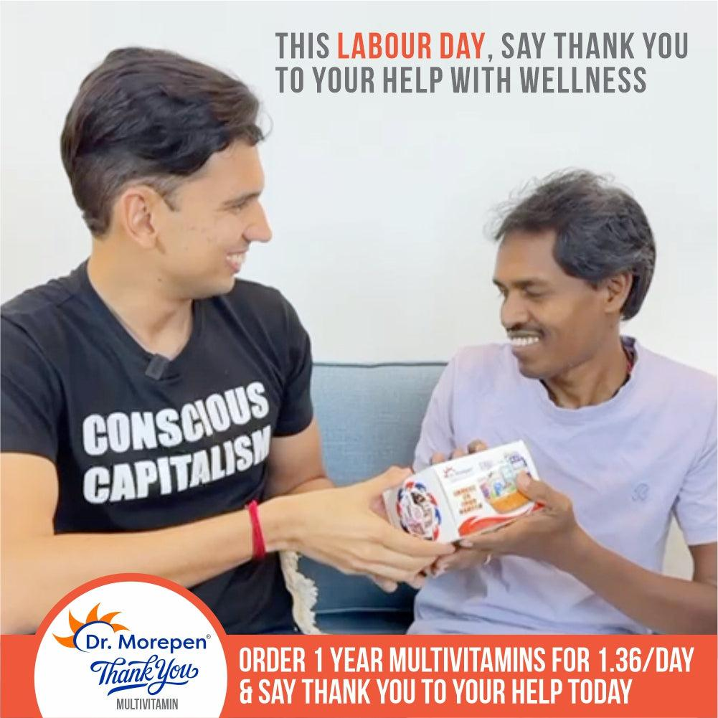In a powerful alignment of purpose, this movement is also being supported by leading health educator and content creator, Revant Himatsingka, popularly known as ***FoodPharmer*.**

Through his platform, *FoodPharmer* continues to advocate for healthier, more accessible food and supplement choices in India—and has joined hands with Dr. Morepen to amplify this mission of public health equity.

*“When gratitude is combined with action, it can save lives. Let’s thank the ones who help us live better, by helping them live healthier,”* expresses *FoodPharmer*

Varun Suri shared in a statement expressing gratitude to Revant for backing the initiative.

India still battles alarmingly high rates of undernutrition, especially among low-income groups. ‘Thank You’ invites every Indian to make a difference—not with grand gestures, but with a simple act of care.

Dr. Morepen “Thankyou” is a perfect, scientifically designed multivitamin containing all essential vitamins all in one pack.

[Buy Dr. Morepen Thank You Multivitamin Now](https://health.drmorepen.com/products/dr-morepen-thankyou?srsltid=AfmBOoqiOlbWV67lI5Wlv-ypcWG_5vYWonF0ngfBgJckVuZiakBElDvg)

**About Dr. Morepen**

Dr. Morepen Ltd. is a subsidiary of Morepen Laboratories Limited. Established in 2001, Dr. Morepen is driven by the philosophy of “Health in Your Hands,” a mantra that resonates with contemporary life full of hectic schedules, impending deadlines, and tough competition. The brand is built on two core values: health and empowerment, encapsulated by the punchline “health in your hands.” Certified by the “Limca Book of Records” as the first company to redefine the OTC category as FMHG, Dr. Morepen takes pride in owning iconic products like Burnol and Lemolate.

**For more information**

Nitika Saini, Corporate Communications Manager

Mobile: 9818533004  
Email: nitika.saini@morepen.com